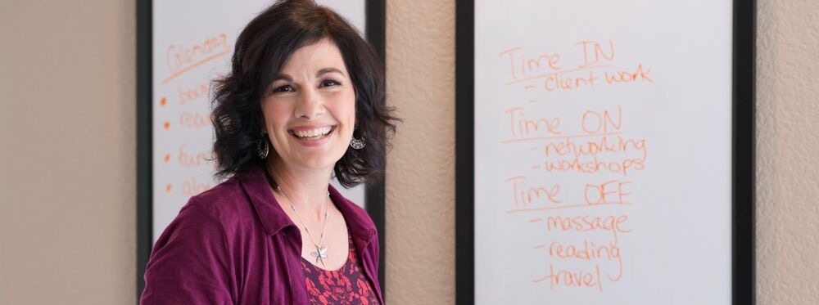

Which Zones are you spending your time in?
As identified by author Gay Hendricks in The Big Leap, our activities occur in four main zones. Taking the time and going through a process to help you identify which zone you are spending the majority of your time can create great awareness and a powerful starting point. Beginning to shift spending time in the zone of incompetence and zone of competence to be more in your zone of genius creates more ease and joy in your business and in your life.

The zone of Incompetence
“The Zone of Incompetence is made up of all the activities we’re not good at. Others can do them a lot better than we can. Surprisingly, many successful people persist in wasting time and energy doing things for which they have no talent.”

The Zone of Competence
“You’re competent at the activities in the Zone of Competence, but others can do them just as well.”

The Zone of Excellence
“In the Zone of Excellence are the activities you do extremely well. You make a good living in your Zone of Excellence...this zone is a seductive and even dangerous trap…it’s where your own addiction to comfort wants you to stay…you’re reliable there, and you provide a steady supply of all the things that family, friends, and organizations thrive on.”

The Zone of Genius
“Liberating and expressing your natural genius is your ultimate path to success and life satisfaction. Your Zone of Genius is the set of activities you are uniquely suited to do. They draw upon your special gifts and strengths. Your Zone of Genius beckons you with increasingly strong calls as you go through your life.”
Once you become aware of which Zones you are spending your time in, from there you can begin to make shifts and make changes to be spending more time in your Zone of Genius!

​If you'd like to learn more about these Zones and how to begin to shift your time to living more in your Zone of Genius, schedule time with me and we’ll connect and talk about how I can best support you.
Schedule your FREE 30-Minute Strategy Evaluation and take your first step toward getting the support needed to grow your business, ease your mind, and live a life of more abundance! www.tinyurl.com/MeetWithJanina
Your Mindset & Process Strategist,

